**CosmiCode** **internship**

**Internee Name: Mustafa Ihsan**

**Week 1: Introduction to Cybersecurity**

Set up a virtual machine (Kali Linux or any Linux distro)

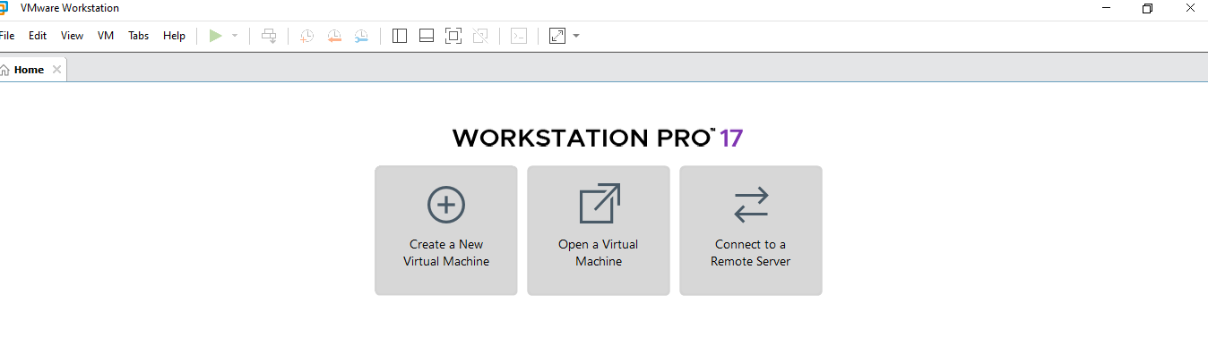

Configure basic network settings on the virtual machine:

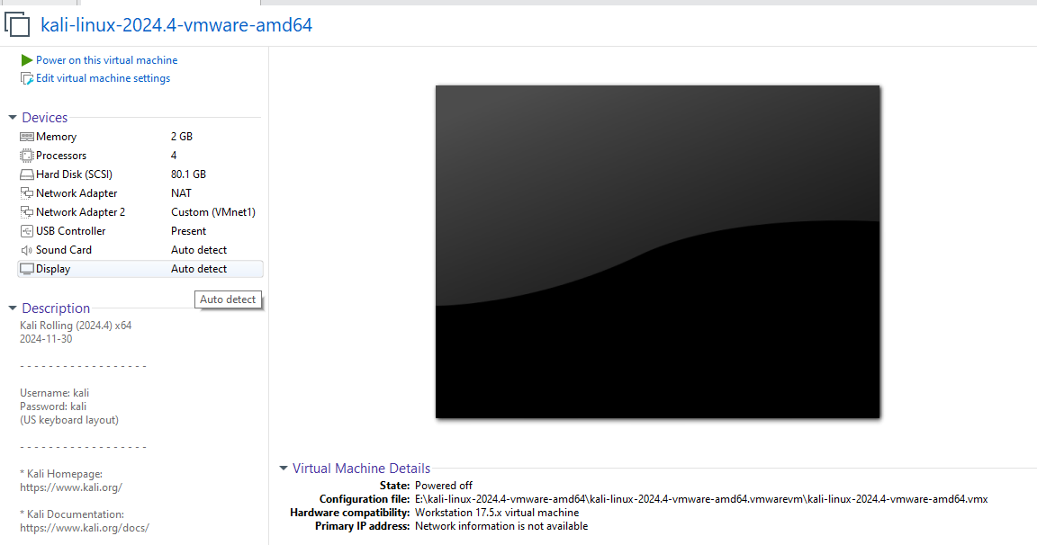

Use Nmap to scan your local network and identify connected devices:

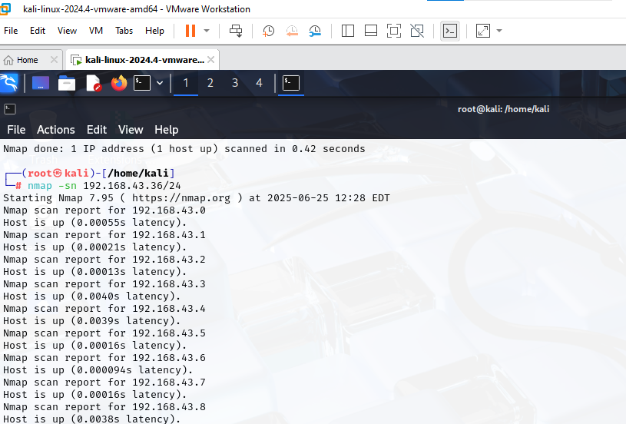

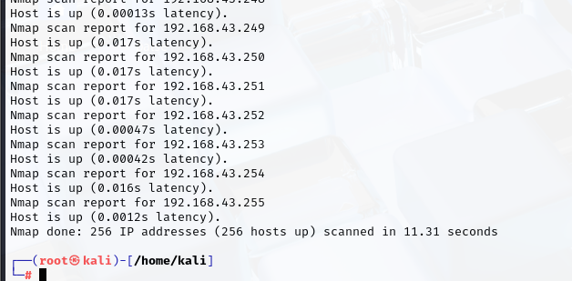

Capture network traffic using Wireshark and analyze the data

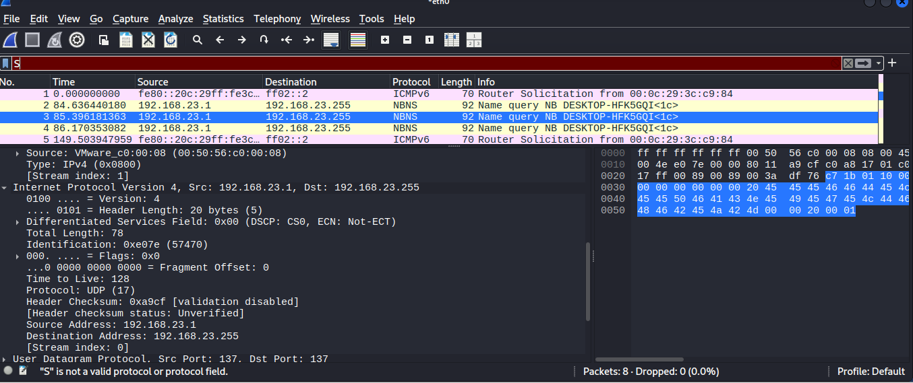

Perform a basic port scan on your own machine

